The Gospel is for all  Studies in the Book of Acts | Abstract  Jesus has died for the sins of the world and the book of Acts tells the story of that message of salvation being spread through the Roman Empire.  John Gibson

Contents
Remembrance Passages 4
Palestine in the First Century 6
Nations Present at Pentecost 8
Paul’s First Journey 10
Paul’s Second Journey 12
Paul’s Third Journey 14
Journey to Rome 16
Lesson One: Waiting for the Holy Spirit 18
Luke 24:36-53; Acts 1 18
Lesson Two: The Holy Spirit Comes! 20
Acts 2, 3 20
Lesson Three: God Helps People Teach the Gospel 22
Acts 4, 5 22
Lesson Four: Courage to Teach the Gospel 24
Acts 6:1—8:3 24
Lesson Five: Teaching the Gospel to an Ethiopian 26
Acts 8, 9 26
Lesson Six: Teaching the Gospel to a Gentile 28
Acts 10, 11 28
Lesson Seven: Teaching the Gospel to More People 30
Acts 12-14 30
Lesson Eight: Teaching the Gospel in Other Countries 34
Acts 15, 16 34
Lesson Nine: Teaching the Gospel All Over the World 36
Acts 17, 18 36
Lesson Ten: Changing the World with the Gospel 38
Acts 19:1—21:14 38
Lesson Eleven: Persecuted for Preaching the Gospel 40
Acts 21:15—23:35 40
Lesson Twelve: On Trial for Preaching the Gospel 42
Acts 24-26 42
Lesson Thirteen: Preaching the Gospel from Prison 46
Acts 27, 28 46

Remembrance Passages

Lessons 1-4
“Now when they heard this, they were cut to the heart, and said to Peter and the rest of the apostles, ‘Men and brethren, what shall we do?’ Then Peter said to them, ‘Repent, and let every one of you be baptized in the name of Jesus Christ for the remission of sins; and you shall receive the gift of the Holy Spirit.’ ” Acts 2:37-38
Lessons 5-8
“Then Peter opened his mouth and said: ‘In truth I perceive that God shows no partiality. But in every nation whoever fears Him and works righteousness is accepted by Him.’ ” Acts 10:34-35
Lessons 9-13
“Then Paul, as his custom was, went in to them, and for three Sabbaths reasoned with them from the Scriptures, explaining and demonstrating that the Christ had to suffer and rise again from the dead, and saying, ‘This Jesus whom I preach to you is the Christ.’ ” Acts 17:2-3

Palestine in the First Century

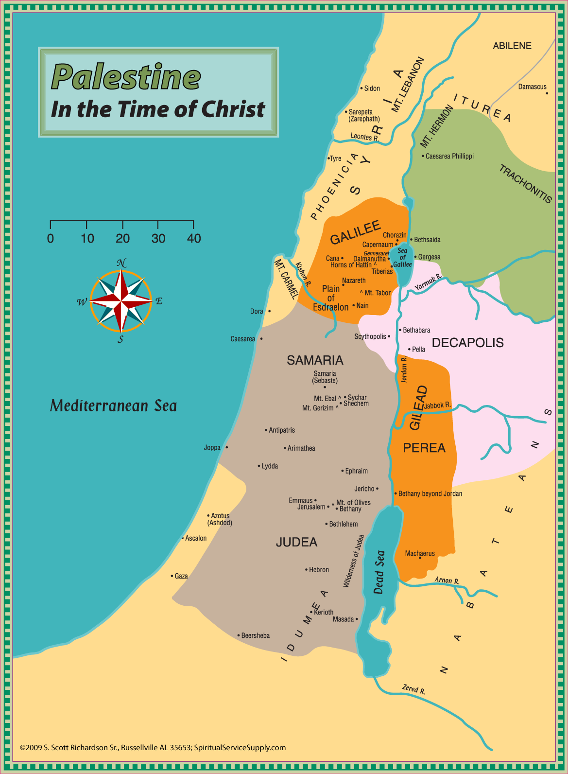

Nations Present at Pentecost
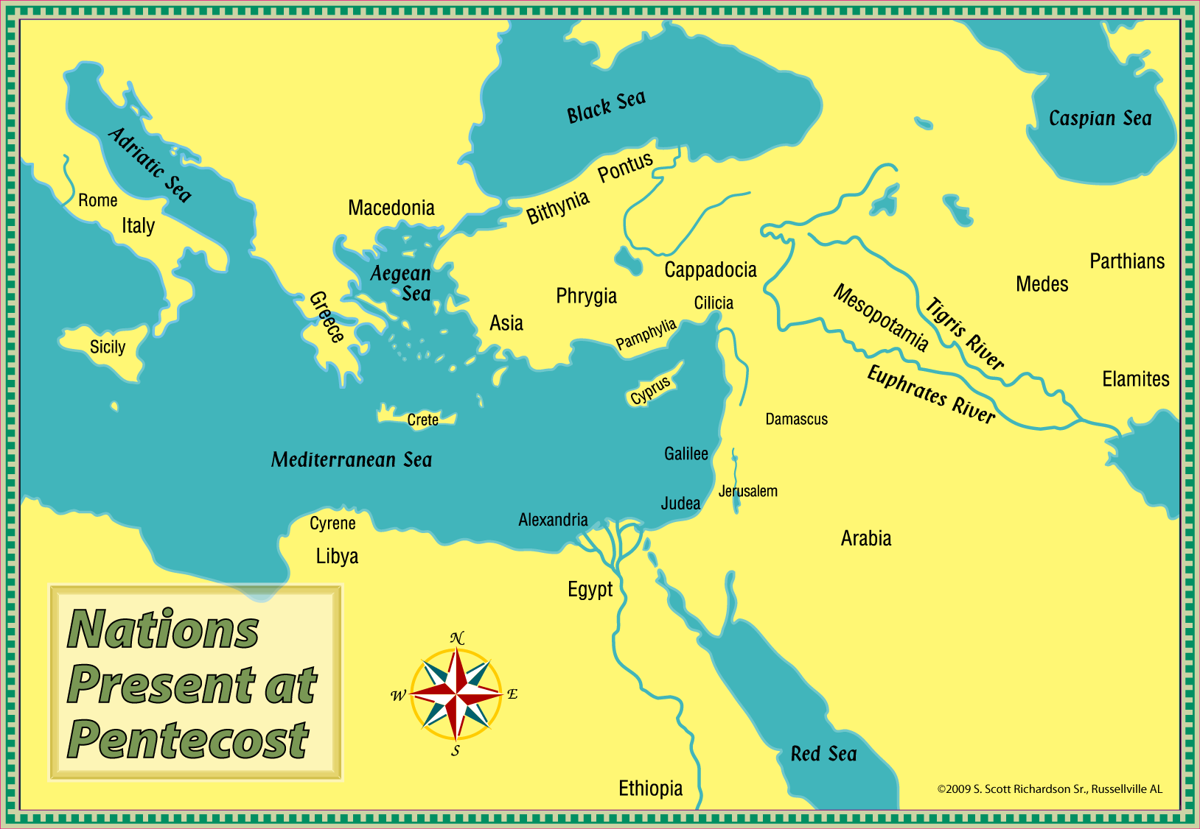

Paul’s First Journey
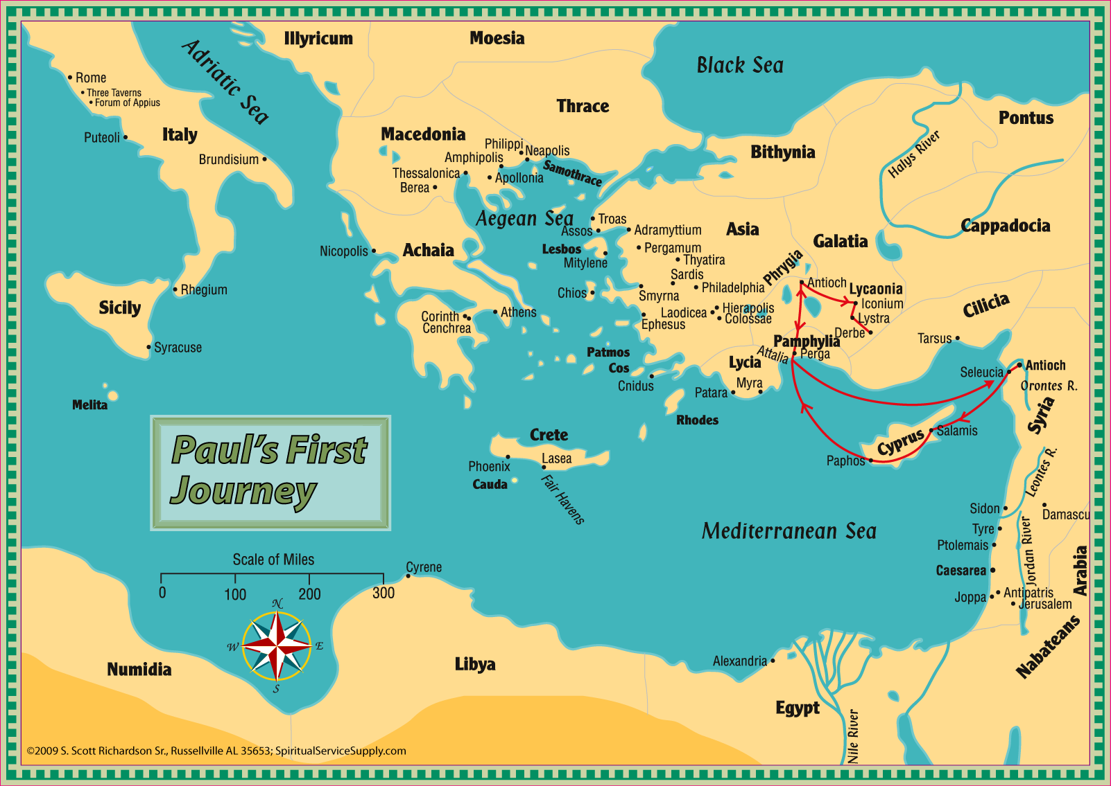

Paul’s Second Journey
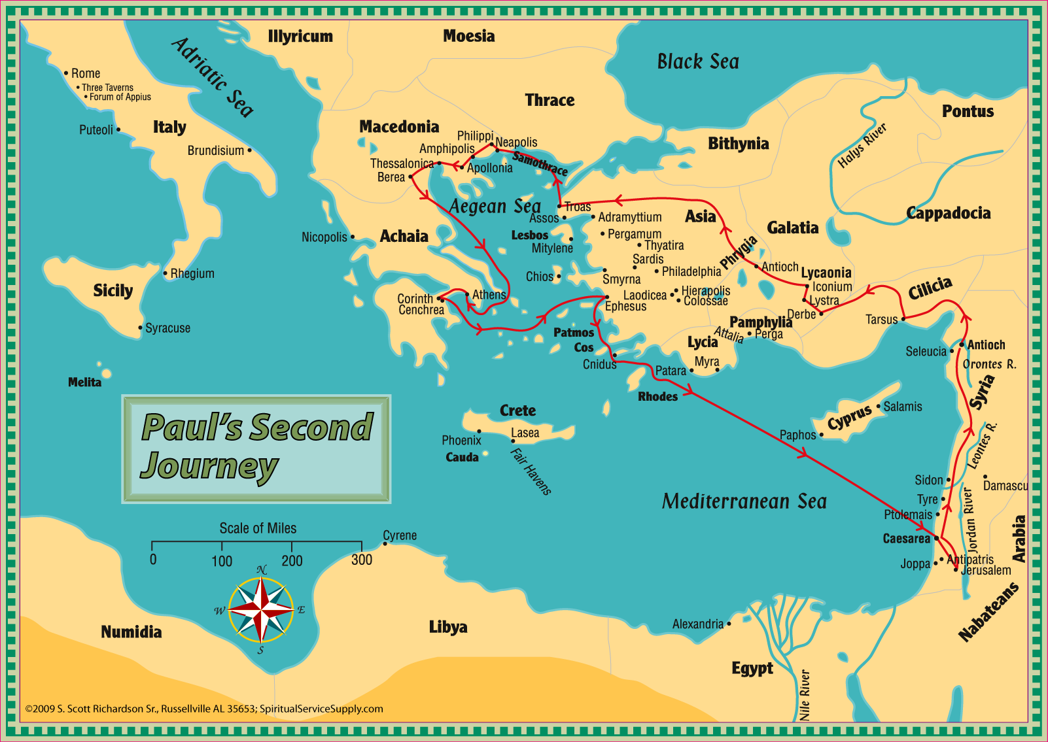

Paul’s Third Journey
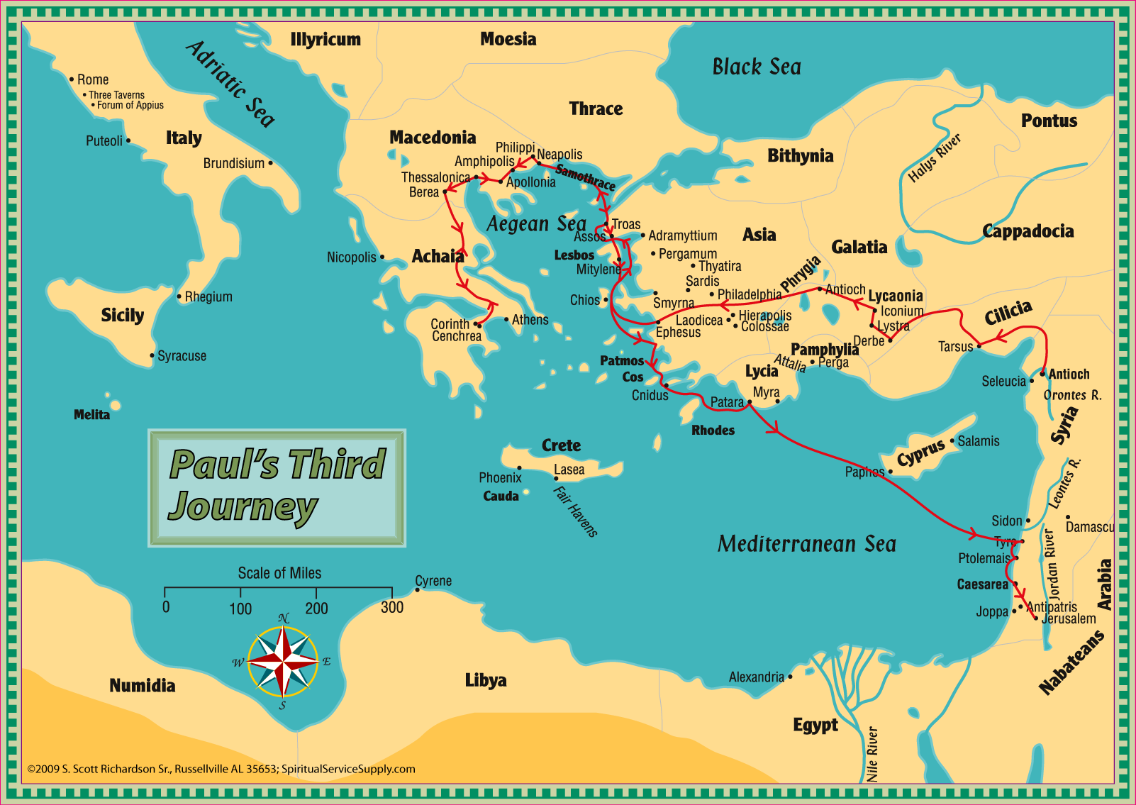

Journey to Rome
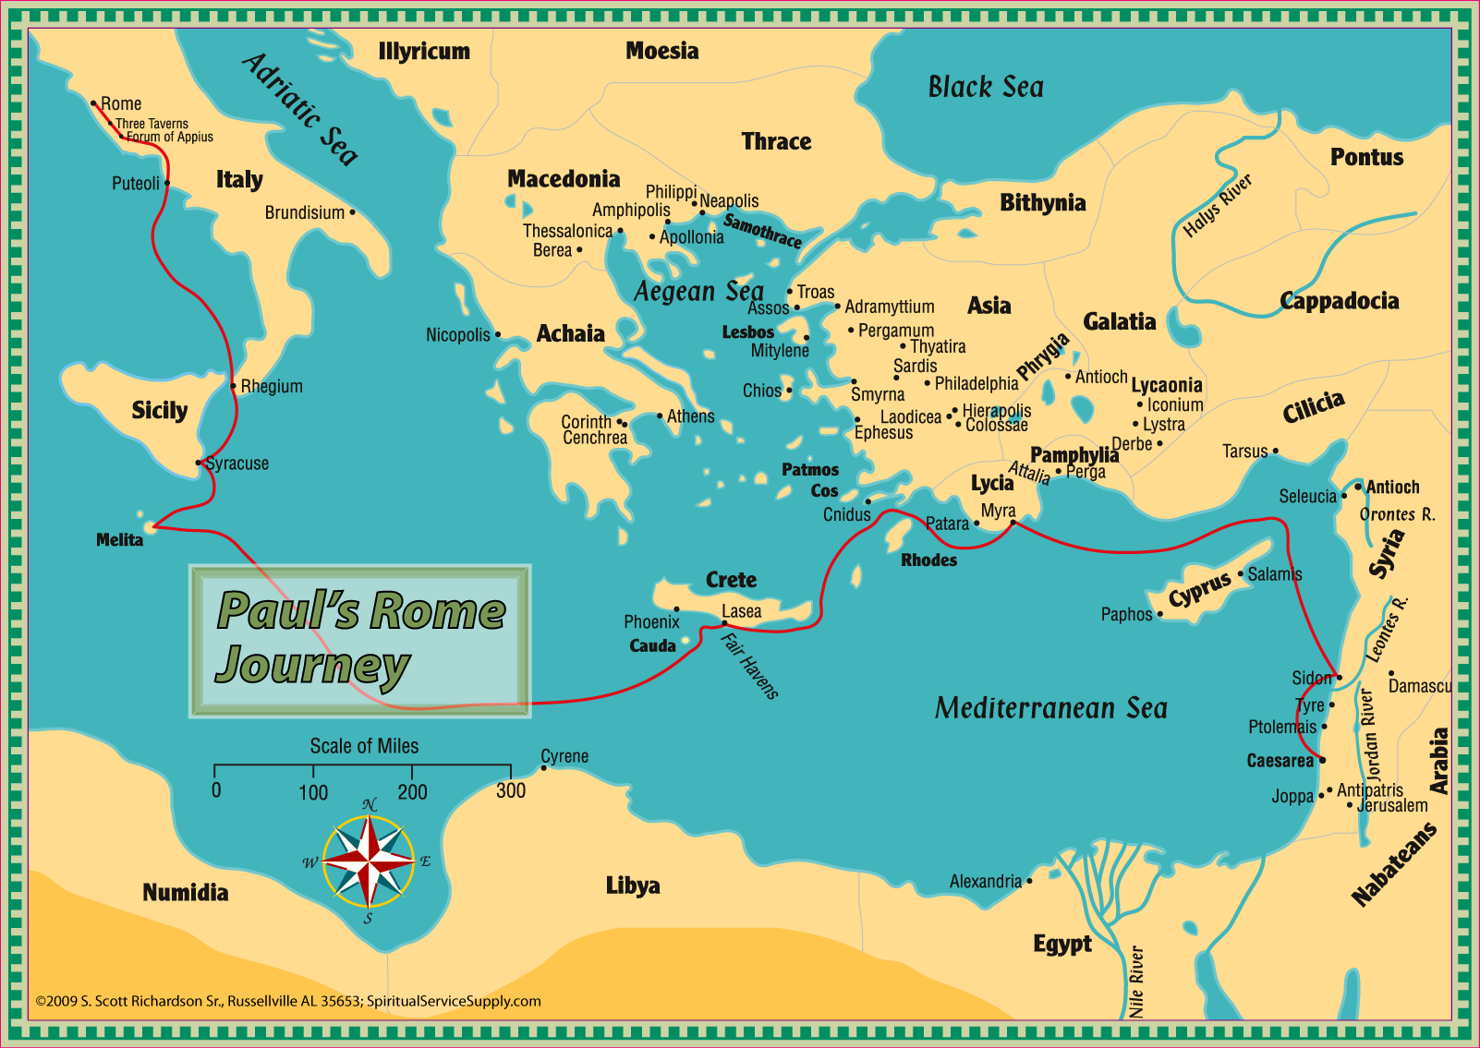

Lesson One: Waiting for the Holy Spirit

Luke 24:36-53; Acts 1

1. As we study the book of Acts…
a. The accounts of dedication and sacrifice should spark our zeal.
b. We will find detailed accounts of how people were converted and came to salvation in Christ.
c. It should help us better understand the Holy Spirit, speaking in tongues, and His part in conversion.
d. We will better understand what a local church should be and do.
2. Who wrote Acts?
3. The Acts of the Apostles as a title can be somewhat misleading. How many of the 12 are mentioned by name after ch. 1?
4. Acts is the story of the Great Commission being carried out. Matt. 28:16-20; Mk. 16:14-20; Lk. 24:44-49; Acts 1:8.
5. Two key divisions of the book.
a. Ch. 1-12 Story of Peter and the gospel in and around Jerusalem. (Also Philip and Samaria.)
b. Ch. 13-28 Paul and the Gentiles.
6. Who is Theophilus and what is the former account mentioned in 1:1?
7. How long was the gap between Passover and Pentecost?
8. Some of those “40 day” discussions took place in Galilee, but why were they instructed in Acts 1 to remain in Jerusalem?
9. What was their question when told to wait in Jerusalem?
10. What would they do when the Holy Spirit came upon them?
11. Luke 24:49-53 tells us that Jesus was separated from the apostles as He did what?
12. What was a Sabbath day’s journey?
13. What did the apostles do when they returned to Jerusalem?
14. Note: Acts 1:14 is the last time Mary is mentioned by name in the New Testament.
15. The events of 1:15-26 probably took place somewhere other than the upper room. Cf. Lk. 24:52-53.
16. What does it mean when it says a Scripture was fulfilled?
17. Locate the two Psalms quoted in 1:20.
18. List the requirements for the one who would be the replacement for Judas.
19. What two men were put forward as possible replacements?
20. How did they choose between the two?

Lesson Two: The Holy Spirit Comes!

Acts 2, 3

1. By what name(s) was Pentecost known in the OT?
2. Did the Holy Spirit come upon the 12 apostles or the 120 disciples mentioned in 1:15? (Be prepared to defend your answer.)
3. What three things made it clear that the Holy Spirit had come?

4. What were these tongues?
5. Why were people confused about the things being spoken by the apostles?
6. What was a proselyte?
7. How did Peter answer the charge that they were drunk?
8. Did the apostles explain the moon being turned to blood? For more on the language of judgment used by the prophets, see Isa. 13:1, 6, 9-10, 13, 17-19 and Ezek. 32:1-8.
9. Where else in the NT do we find Joel 2:32 quoted?
10. Read 2:22-24 carefully. What parts of that would the audience have agreed with? What parts would they have disagreed with?
11. Study 2:25-36 carefully. How did Peter seek to prove that Jesus was the Christ and raised from the dead?
12. In John 16:8-9, what had Jesus promised that the Holy Spirit would do? How did He do that on Pentecost?
13. What were those cut to the heart instructed to do?
14. Define repentance.
15. Could “for the remission of sins” mean because of, i.e. be baptized because you have been forgiven?
16. List at least two other passages connecting baptism to salvation and/or forgiveness.
17. The meaning of the gift of the Holy Spirit has troubled many through the years, so give this some careful thought.
a. Is it equating the word with the Holy Spirit as in Eph. 6:17 and a comparison of Eph. 5:18-19 and Col. 3:16?
b. Johnny Stringer in Truth Commentaries argues it has reference to the apostles laying hands on people and giving them the power to perform signs, speak in tongues, etc.
c. Some believe it refers to what is sometimes called the personal or literal indwelling.
d. Finally there is the temple concept (1 Cor. 6:19-20). God did not literally dwell in the OT temple/tabernacle, but it was seen as His house, with His glory in it. This view is that God is with us in a similar way God when we enter into Christ. Ex. 29:44-46; 1 Kgs. 8:10-13, 27, 49; Ezek. 37:26-28; 2 Cor. 6:16-18; Eph. 2:19-22
18. Who were those “afar off” in 2:39?
19. How many were baptized that first day?
20. In what did these new converts continue steadfastly?
a. Was the breaking of bread in 2:42 the Lord’s Supper or a common, social meal?
21. Wonders and signs were done through the __________________.
22. How were the physical needs of some met?
23. Where did they eat their food?
24. Where was the lame man when he saw Peter and John going into the temple in ch. 3?
25. How long had he been lame?
26. How long did it take for the man to get enough strength to begin walking?
27. Where did the crowd gather to hear Peter speak?
28. Peter assured the crowd that the man had not been healed because of his and John’s _____________ or _______________.
29. List the different terms used for Jesus in Peter’s sermon.
a. E.g. “His Servant Jesus.” 3:13

30. Think: why would Peter identify the Lord as the God of Abraham, Isaac, and Jacob?
31. Notice the contrasts in 3:13-15.
a. God glorified Jesus, while they had ____________________ and _________________ Him.
b. They denied the _________________________________, but asked for a murderer.
c. They ___________________ the Prince (Author) of life, but God raised Him from the dead.
32. What was promised to them if they would repent and be converted (turn again)?
33. The Lord had promised to raise up a prophet like ___________________. Cf. John 1:19-21.
34. What would happen to anyone who refused to hear the Prophet?
35. Abraham was promised that in his _______________ all the families of the earth would be ____________.
36. Jesus had been sent to bless them by turning them away from their __________________.

Lesson Three: God Helps People Teach the Gospel

Acts 4, 5

1. Review the events of ch. 3. This chapter is a continuation of the events of that chapter.
2. Why would the sect of the Sadducees have taken the lead in arresting Peter and John?
3. The number of believers had now reached ___________________.
4. Annas had not been the official high priest since about A.D. 15 when the Romans removed him from office, but the Jews continued to honor him as high priest and he wielded great influence during the priesthood of Caiaphas, his son-in-law.
5. What was the first question asked of Peter and John when they appeared before the council?
6. Peter described what they had done as a _______________ deed done to a ______________ man.
7. How did they describe Jesus when crediting Him with healing the lame man?
8. Where in the Old Testament would you find the prophecy of the rejected stone?
9. Find some other New Testament references that point to Jesus as the only way of salvation.
10. Why were the members of the Sanhedrin so amazed at the boldness of Peter and John?
11. Why were they unable to dispute the testimony of the two apostles?
12. Why was the council afraid to do anything more than threaten the apostles?
13. How did Peter and John answer when forbidden to continue speaking and teaching in the name of Jesus?
14. In their prayer of Acts they quoted from Psalm ___________.
15. What did the apostles ask of the Lord in their prayer?
16. How did the Lord answer?
17. 4:32—5:11 expands on some things first mentioned in 2:43-45.
18. List the various ways their unity and concern for one another was expressed in 4:32-35.
19. What was the significance of laying things at the feet of the apostles?
20. How did Joses (Joseph in some texts) earn the name Barnabas?
21. Ananias lied because __________________ filled his __________________.
22. To whom did Ananias lie?
23. Were Christians required to sell their land and other possessions? Were they required to give all of the money they received from the sales?
24. How did the church react/respond to these two deaths?
25. Where did the church gather at this time?
26. To whom were believers increasingly added?
27. Some who were hoping for a miracle took what unusual steps?
28. A multitude gathered from the _________________ ____________________ to Jerusalem.
29. How were the apostles able to get out of prison?
30. When did they return to the temple to resume preaching?
31. What report did the officers bring back after going to the prison to get the apostles?
32. Why were the arresting officers careful to avoid any violence when they apprehended the apostles?
33. Read Matt. 27:15-26 and note the irony of the complaint in 5:28.
34. We ought to obey _________________ rather than ________________.
35. Why does Peter use the expression “hanging on a tree” to describe the crucifixion? Cf. Gal. 3:13.
36. The exalted Christ would give Israel what two things?
37. Who were the witnesses to the exaltation of Jesus?
38. What do we know about Gamaliel? (This is not the only time he is mentioned in Acts.)
39. How did Gamaliel persuade the council not to kill the apostles? Was Gamaliel’s reasoning sound?
40. What did the apostles do after being beaten and commanded not to speak in the name of Jesus?

Lesson Four: Courage to Teach the Gospel

Acts 6:1—8:3

1. What caused the complaint at the beginning of this chapter?
2. The apostles summoned the ___________________ of the __________________.
3. Why did the apostles not want to have the full responsibility for serving tables?
4. What was the proposed solution?
5. What qualities did the seven need to possess?
6. After the church as a whole selected the seven men, the apostles ________________ and laid ________________ on them.
7. How many of the seven are mentioned again in the book of Acts?
8. The problem was resolved and the number of the disciples _____________________.
9. What specific group of converts did Luke single out as noteworthy?
10. In 6:8 we read of Stephen doing great wonders and signs among the people—the first time since Pentecost anyone other than an apostle is said to have worked miracles.
11. Why did some secretly induce (instigate) false witnesses to testify against Stephen?
12. What specific charges were made against Stephen?
13. What was meant by his face looking like that of an angel?
14. As you read Stephen’s speech take note of any recurring theme(s) you see.
15. Where was Abraham when the Lord first spoke to him?
16. Why did the patriarchs sell Joseph into Egypt?
17. How large was the family when they moved to Egypt?
18. When the time of the _________________ drew near. Cf. 7:17 and 7:5.
19. Moses is said to have been mighty in _________________ and _______________, though he described himself as slow of _________________ and ________________ in Ex. 4:10.
20. Why, when he was forty years old, did Moses kill an Egyptian?
21. Where was Moses when God appeared to Him and why did he have to take off his sandals?
22. Take note of how Moses is described in v. 35.
23. Moses delivered the people after he had shown _______________ and _____________. Cf. 2:22.
24. The people of old had rejected Moses, the one who had spoken of a ________________ like himself being raised up. Cf. 3:22-23.
25. The people rejected Moses and turned back to _________________ in their _________________.
26. Stephen sought to open their eyes to the possibility of being wrong by pointing out Israel’s history of rebellion. Which one of the minor prophets is quoted in 7:4
27. Where was Israel when the first tabernacle was built?
28. The conquest of Canaan was led by ________________, whose name in Greek translates as Jesus.
29. Though Solomon built the Lord a house, the Most High does not dwell in ______________ made with ______________.
30. How was Stephen’s speech received?
31. Note that 7:55 is the only time we read of Jesus standing instead of sitting at the right hand of God.
32. What did the witnesses do with their clothes?
33. What did Stephen do as he was dying?
34. How did Saul/Paul describe His actions in Acts 22:4 and 26:9-11?

Lesson Five: Teaching the Gospel to an Ethiopian

Acts 8, 9

1. The scattered disciples went everywhere doing what? What group of disciples was said to have remained in Jerusalem?
2. Why did the people of Samaria pay attention to the preaching of Philip?
3. Simon had previously been able to impress the people with his practice of __________________.
4. What did Philip preach in Samaria? 8:4-5, 12
5. How did people respond to this preaching?
6. Was Simon a genuine convert or just a pretender? Be able to support your answer.
7. Why did Peter and John go to Samaria?
8. What did Simon see that caused him to offer money to Peter and John?
9. Because Simon’s heart was corrupted, he needed to ________________ and ______________.
10. What did Peter and John do on their journey back to Jerusalem?
11. Who directed Philip to leave Samaria and head south?
12. What position of authority did the eunuch have?
13. The eunuch was reading from the prophet _________________.
14. What was his question about the passage he was reading?
15. What did Philip preach to the eunuch?
16. What prompted the eunuch’s question about baptism?
17. Describe the actions taken to baptize the eunuch.
18. The Ethiopian went on his way ___________________.
19. Philip worked his way north until he came to __________________.
20. Read Acts 22:1-16 and 26:1-20 for a fuller picture of the events surrounding the conversion of Saul.
21. Why did Saul go to Damascus? How far was it from Jerusalem to Damascus?
22. What time of day did the light appear to Saul? How bright was this light?
23. Could his travel companions hear the voice as it conversed with Saul?
24. Did Jesus declare Saul’s sins forgiven? Did the Lord tell him what he needed to do to be saved?
25. What did Saul do for the next three days?
26. Where did he lodge for those three days?
27. How did Ananias react when he was told to go and find Saul?
28. The Lord gave Ananias assurance that Saul was a chosen ___________________ to carry the name of Jesus before _____________________, _____________________, and the children of __________________.
29. How was Saul’s sight restored?
30. In 22:16, Saul was told to be baptized and _________________ _________________ his sins.
31. Immediately after his conversion he began to preach Christ in the _____________________.
32. How was he able to escape a plot on his life at Damascus?
33. Who came to Saul’s aid when he attempted to join the disciples at Jerusalem?
34. Why did the brethren in Jerusalem send Saul to his hometown of Tarsus?
35. The church throughout the region then enjoyed a period of _________________ and was _______________.
36. Be sure to follow Peter’s journeys in ch. 9, 10 on the map.
37. How long had Aeneas been bedridden?
38. What impact did the healing of Aeneas have on the people in that region?
39. What did the names Tabitha and Dorcas mean?
40. Dorcas was said to be full of _____________________________.
41. Who was weeping when Peter arrived in Joppa?
42. Peter lodged with __________________.

Lesson Six: Teaching the Gospel to a Gentile

Acts 10, 11

1. Some historical background:
a. Centurions had authority over approximately 80-100 men.
b. A regiment (or cohort) was usually comprised of about 600 men.
c. The Italian Regiment (Cohort) likely referred to a regiment comprised of Italian volunteers.
2. How are the character and spiritual qualities of Cornelius described?
3. At what time of the day did the angel appear to Cornelius as he was praying?
4. Because his prayers had been heard, Cornelius was told to do what?
5. How many men did Cornelius send to Joppa?
6. When did Peter go on the housetop to pray?
7. Describe the vision Peter saw and what the voice said.
8. How many times was the vision repeated?
9. When did the men sent by Cornelius arrive at the house of Simon?
10. Take note of 10:23 and the reference to brethren from Joppa. These play an important role in ch. 11.
11. Cornelius had invited ________________________ and _____________________ to hear Peter.
12. What did Cornelius do when Peter walked in and what was Peter’s response?
13. How had the Lord shown Peter that he was not to call any man common or unclean?
14. Cornelius declared that they wanted to hear all the things _____________________ by God.
15. Thinking back: Jesus had instructed the apostles to make disciples of whom (Matt. 28:18-20)? They were to preach the gospel to _______________ _________________. Mark 16:15
16. What quality of God means that all who fear Him and work righteousness will be accepted?
17. Jesus is described as Lord of whom?
18. To whom did Jesus appear after His resurrection?
19. What caused astonishment to those of the circumcision, i.e. the brethren from Joppa?
20. When the Holy Spirit had come on Cornelius and the others present, what was Peter’s question?
21. The apostles and brethren in Judea heard that the Gentiles had received the ____________________.
22. What was the complaint against Peter lodged by some in Jerusalem?
23. How many witnesses had accompanied Peter from Joppa to Caesarea?
24. Peter to tell Cornelius _________________ by which he would be saved.
25. To what event did Peter compare the Holy Spirit falling on Cornelius and his household?
26. How did the people respond to Peter’s defense of his conduct with the Gentiles?
27. Use a map to locate the various places mentioned in 11:19.
28. Notes on Antioch.
a. Selucius, a general of Alexander the Great, founded the city and named it after his son.
b. There were a number of other cities with the same name, but Antioch on the Orontes (sometimes called Antioch of Syria) was the largest and most prominent.
c. With a population estimated to have been somewhere between 400,000 and 600,000, it is thought to have been the third largest city of the Roman Empire in the first century, behind only Rome and Alexandria.
29. At Antioch, who took the lead in preaching to the Hellenists (Grecians, Greeks)?
30. Take note of a point of emphasis in this section.
a. They were preaching the _____________ ______________. 11:20
b. People believed and turned to ___________________. 11:21
c. They were urged to continue with ____________________. 11:23
d. A great many people were added to ____________________. 11:24
31. Why did Barnabas go to Antioch?
32. What did Barnabas “see” when he arrived?
33. With ______________________________ they were to continue with the Lord .
34. Where did Barnabas go to get Saul?
35. It was here at Antioch that the disciples were first called _________________________.
36. How did the disciples at Antioch respond to the prophecy of Agabus?
37. To whom did Barnabas and Saul carry the relief?

Lesson Seven: Teaching the Gospel to More People

Acts 12-14

1. Herod the king was…
a. Also known as Agrippa I.
b. The grandson of Herod the Great, the one who sought to kill Jesus as a baby.
c. A nephew of Herod Antipas, the one before whom Jesus stood trial.
d. The grandson of Mariamne, a princess of the Hasmonean dynasty.
2. Herod killed _________________ and then arrested Peter because it pleased the _______________.
3. How many men were charged with guarding Peter?
4. When did Herod intend to execute Peter?
5. What did Peter think was happening when the angel appeared to him and told him to get dressed?
6. How did Peter and the angel get out of the iron gate?
7. Where did Peter go after the angel disappeared?
8. What did Rhoda do when she recognized Peter’s voice?
9. Peter wanted them to get the word to ________________ and the other brethren.
10. What happened to the guards who in charge of Peter?
11. Why were the people of Tyre and Sidon eager to settle their dispute with Herod?
12. Because he did not give ________________ to God, Herod was eaten by ________________.
13. While Herod died, the word of God did what?
14. List the five prophets and teachers specifically named at Antioch.
15. What were they doing when the Holy Spirit directed them to separate Barnabas and Saul for a special work?
16. Be sure to follow this journey on a map.
17. Where did they preach after they arrived on the island of Cyprus?
18. At Paphos they were opposed by _________________, a _________________ and _____________ ____________, also known as ___________________.
19. At what point did John (Mark) turn back?
20. At Antioch of Pisidia, they went into the __________________ on the Sabbath.
21. While both Paul and Stephen (ch. 7) utilized Israel’s history, the points emphasized in this chapter are different from those in ch. 7.
22. Who was the first king of Israel?
23. God was said to have raised up a Savior from the seed of what man?
24. What kind of baptism did John preach? To whom did he preach it?
25. What was John’s message as he was finishing his course?
26. Jesus was killed, in part, because the rulers of the Jews did not know the voices of the ________________, though they were ________________ every __________________.
27. When they crucified Jesus they were ___________________ all that was written concerning Him.
28. That Jesus was raised from the dead was confirmed by…
a. Witnesses who had come with Him from _________________.
b. Three prophetic passages. Locate the Old Testament sources for the quotations in 13:33-35.
29. What happened to David after he had served his own generation by the will of God (or, served the purpose of God in his own generation—ESV)?
30. In contrast to what the Law of Moses could not do, in Jesus one could be _________________ from all things.
31. Who begged to hear more?
32. Paul and Barnabas persuaded/urged those following them to _____________ in the _____________ of God.
33. What sinful attitude motivated many of the Jews to oppose Paul the next Sabbath?
34. Why did Paul and Barnabas turn to the Gentiles?
35. What two groups did the Jews stir up to create persecution against Paul and Barnabas?
36. Despite the persecution, the new disciples were described as filled with _______________ and the _____________ __________________.
37. In the initial response at Iconium, a _____________ _________________ believed.
38. Who took the lead in stirring up trouble in that city?
39. How did the Lord bear witness to the word of His grace?
40. When did Paul and Barnabas decide it was best to move on to Lystra and Derbe?
41. What was the cry of the people of Lystra when they saw the lame man leap and walk?
42. Barnabas was called __________________ and Paul, as the chief speaker, was given the name _______________.
43. What did Paul and Barnabas do when they realized sacrifices were about to be offered?

44. They sought to stop this worship by…
a. Declaring that they were men with the same what?
b. Urging them to turn from ___________ __________ to the _____________ ____________.
45. Though the Lord had not always spoken to the Gentiles, what witness had He left of Himself?
46. Who turned the people of Lystra from being in awe of Paul and Barnabas to seeking to kill Paul?
47. What resulted from their preaching in Derbe?
48. What was the message of Paul and Barnabas as they returned through the cities of Lystra, Iconium, and Antioch?
49. At Antioch, Paul and Barnabas gathered the church and reported that God had done what?

Lesson Eight: Teaching the Gospel in Other Countries

Acts 15, 16

1. There is some dispute about the relationship between Gal. 2 and Acts 15.
a. Some believe Galatians was written shortly after the completion of the first journey, which would mean the visit in Gal. 2 coincided with the relief effort mentioned at the end of Acts 11.
b. Others believe that Galatians was written sometime during the second or third journeys and Gal. 2 refers to the visit in Acts 15.
c. In my mind, the former better explains why Galatians never references the decrees delivered in Acts 16:4, though the latter is easier to reconcile with the years mentioned in Gal. 1:18; 2:1.
2. What were the brethren from Judea teaching in Antioch? 15:1, 5
3. How did Paul and Barnabas react to this?
4. Why were Paul and Barnabas sent to Jerusalem? If Paul was an apostle, why wasn’t his word definitive?
5. What did Paul and Barnabas do as they made their way to Jerusalem?
6. The chief “Judaizers” were believers who had come from the sect of the ___________________.
7. While 15:6 speaks of the apostles and elders coming together, 15:12, 22 indicate many more were present.
8. What went on before Peter rose up to speak?
9. How did the Lord show through Cornelius that the Gentiles were to be accepted without being required to be circumcised?
10. What yoke was Peter referring to in 15:10?
11. What proof did Barnabas and Paul offer that the Gentiles were not required to be circumcised?
12. Though he used the plural prophets, what one prophet did James cite in his argument?
13. What conclusion did James offer?

14. Who was said to have been pleased to send Judas and Silas to Antioch with Paul and Barnabas?
15. Though the Judaizers were said to have troubled and unsettled people, the apostles and elders asserted that they had not done what for them?
16. How did the Christians at Antioch react to the letter from Jerusalem?
17. What reason did Paul give Barnabas for wanting to return to the places where they had previously preached?
18. Why did Paul and Barnabas end up going separate ways?
19. Barnabas went to __________________ and Paul took Silas with him through ________________ and ___________________.
20. Research: Who was Timothy’s mother? Grandmother?
21. Why did Paul circumcise Timothy? Cf. Titus in Gal. 2:1-5.
22. What decrees were they delivering to the churches? 16:4
23. So the ___________________ (plural) were strengthened in the _________________ (singular).
24. The Holy Spirit did not allow Paul to go into what two regions?
25. Why did they decide to go into Macedonia?
26. Take note of something significant in 16:10. The writer switches from “they” and “them” to “us” and “we.” Pay attention to when the “we” sections of Acts begin and end.
27. Try to research the following.
a. The name Philippi honored what man?
b. What was the significance of saying it was a colony?
28. Where did Paul and his company go on the Sabbath? Where did they usually go on the Sabbath?
29. What was Lydia’s hometown? Locate it on a map.
30. How did the Lord open the heart of Lydia? Cf. Acts 26:17-20.
31. After being baptized, Lydia begged Paul and his company to do what? Cf. Phil. 1:3-5.
32. How did a slave girl annoy Paul? Why was he bothered by what she said?
33. This is the first recorded time persecution is initiated by Gentiles, but their reasons are not the same as those of the Jews. Why did the girl’s masters drag Paul and Silas before the authorities?
34. When they had them before the magistrates, they accused Paul and Silas of what?
35. How were Paul and Silas punished?
36. At midnight, Paul and Silas were _______________________ and ______________________.
37. Why did the keeper of the prison draw his sword to kill himself?
38. Was the jailer told he would be saved by faith alone?
39. When were he and his household baptized?
40. Why did Paul refuse to leave the prison the next morning?
41. What did he and Silas do before leaving Philippi?

Lesson Nine: Teaching the Gospel All Over the World

Acts 17, 18

1. Don’t forget to follow Paul’s travels on a map.
2. Paul spent _____________ Sabbaths reasoning from the Scriptures in the synagogue.
3. List some Scriptures which foretold the death and/or resurrection of the Christ (Messiah).
4. Believers are said to have come from what three groups?
5. What two Thessalonians are listed as part of Paul’s company in Acts 20:1-5?
6. Whom did the Jews use to set the city in an uproar?
7. Why was the house of Jason attacked?
8. Paul and his company were accused of turning the ___________ _______________ ___________.
9. How long did Paul stay in Thessalonica after the assault on Jason’s house?
10. Upon arrival in Berea, they again went into the _________________ of the __________________.
11. How were the Jews of Berea different from those of Thessalonica?
12. ________________ from Thessalonica stirred up the crowds in Berea.
13. Paul was taken to __________________, while ____________________ and _________________ initially remained in Berea.
14. Though Acts 17 makes no mention of it, 1 Thes. 3:1-7 indicates that Timothy briefly rejoined Paul in Athens but was sent back to check on the Thessalonians.
15. What stirred the spirit of Paul while he was waiting in Athens?
16. As he waited, he was said to have reasoned with people in what two locations?
17. Research assignment: what were the philosophies of the Epicureans and Stoics?
18. What part of Paul’s preaching was especially puzzling to these philosophers?
19. Paul found an altar inscribed, “To the _____________ _________________.”
20. The true God, the Creator, does not dwell in what?
21. Though the nations had their own dwellings, God wanted them all to ________________ the Lord.
22. If man is the offspring of God, then the Divine Nature (the Godhead—KJV, the divine being—ESV) must not be like what things?
23. God now commands all men to ___________________.
24. What assurance has the Lord given that a day of judgment is coming?
26. Though Paul doesn’t seem to have had great success in Athens, _________________ the Areopagite and a woman named _________________________ believed.
27. Aquila was born in ___________________, but had recently come from ________________.
28. What emperor was responsible for the expulsion of the Jews ca. A.D. 49?
29. Why did Paul choose to stay with Aquila and Priscilla?
30. List three epistles in which Aquila and Priscilla (Prisca) are mentioned?
31. Paul’s preaching seems to have taken on a greater intensity when Silas and Timothy arrived from
_________________.
32. Where did Paul go when forced to leave the synagogue?
33. What position did Crispus hold?
34. Cf. Acts 18:8 with 1 Cor. 6:9-11 to better understand the background of many of these new converts.
35. What reasons were given for Paul not to be afraid?
36. Paul continued teaching there for a ________________ and ______________ ________________.
37. What was Gallio’s response when Paul was brought before his judgment seat?
38. Note: Gallio was proconsul of Corinth ca. A.D. 51-52.
39. Who accompanied Paul when he left Corinth?
40. Why did Paul have his hair cut off at Cenchrea?
41. What request was made by the Jews in Ephesus?
42. Where did Paul spend some time before embarking on the third journey?
43. Though Apollos was said to have been instructed in the way of the Lord, he didn’t know about what?
44. Who helped him to know the way of God more accurately?
45. What did the brethren at Ephesus do for Apollos when he wanted to cross over to Achaia?
46. How did he help the believers in Achaia?

Lesson Ten: Changing the World with the Gospel

Acts 19:1—21:14

1. Where was Apollos when Paul arrived in Ephesus?
2. What question did Paul ask the disciples he met when he first arrived in Ephesus?
3. John the Baptist preached a baptism of ____________________ and told people to believe on __________________________.
4. Why did these twelve need to be baptized a second time?
5. What happened when Paul laid hands on these men?
6. How long was Paul able to preach in the synagogue before being forced to withdraw from there?
7. Where did he spend the next two years teaching?
8. How much impact did his teaching have?
9. How did Luke describe the miracles God worked through Paul?
10. What was the reply of the evil spirit when the seven sons of Sceva attempted to use the “magic formula?”
11. List the various things said to have resulted from the incident with the sons of Sceva.

12. In 19:21 Paul speaks of his plans to go to Macedonia, Achaia, and Jerusalem. What work was he planning? Cf. 1 Cor. 16:1-8; 2 Cor, 8, 9; Rom. 15:22-33.
13. Why did Demetrius call his fellow craftsmen together?
14. ________________ and _________________, Paul’s companions, were seized and carried into the theater.
15. Who prevented Paul from going into the theater?
16. Why do you think the Jews wanted Alexander to speak?
17. How did the crowd react to Alexander?
20. The city of the Ephesians was said to the temple guardian (keeper) of what two things?
21. Note: assembly in 19:32, 39, 41 is from the Greek ekklesia, which is usually translated church.
22. In what cities of Macedonia had Paul previously preached?
23. Where did Paul spend three months before leaving for Jerusalem?
24. Why did he go back through Macedonia instead of sailing from Achaia?
25. List Paul’s traveling companions on the return to Jerusalem.
26. In what city did Paul gather with the disciples to break bread?
27. Why didn’t Paul want to wait on a ship sailing into Ephesus?
28. Paul claimed to have held back nothing that was __________________ for the Ephesians.
29. Where did he do his teaching? 20:20
30. Did Paul know what to expect when he arrived in Jerusalem?
31. What made him innocent of the blood of all men?
32. The elders were told that they had been made __________________ and were to _______________ the flock.
33. Danger to the church would come from what two directions?
34. What is the word of God able to do? 20:32
35. What was the purpose of Paul’s bringing up his manual labor while living in Ephesus?
36. It is more __________________ to give than to receive. (Where is this statement of Jesus found?)
37. What did these men do when Paul had finished his speech?
38. Why were the Ephesian elders so sad?
39. How long was Paul in Tyre?
40. What did the brethren in Tyre do when it was time for Paul to leave?
41. Where did Paul and his companions stay while in Caesarea?
42. Where did we first read about a prophet named Agabus?
43. How did Agabus act out his prophecy?
44. What was the apostle’s response to the pleas that he not go to Jerusalem?

Lesson Eleven: Persecuted for Preaching the Gospel

Acts 21:15—23:35

1. With whom did Paul and his company plan to lodge while in Jerusalem?
2. From Rom. 15; 1 Cor. 16; 2 Cor. 8, 9, what was something “God had done among the Gentiles through [Paul’s] ministry” that is not specifically mentioned in Acts?
3. What had some of the Jewish believers heard that Paul was teaching those Jews who lived in Gentile cities?
4. How did James suggest Paul quell these concerns?
5. Who stirred up the crowd and laid hands on Paul?
6. Had Paul taken Trophimus into the temple?
7. Who saved the life of Paul?
8. Note: the barracks were in the Tower of Antonia which overlooked the temple and had a stairway that led directly into the Court of the Gentiles.
9. The commander thought Paul was the ____________________ who had stirred up a rebellion.
10. In what language did Paul speak to the commander? In what language did he address the crowd?
11. What got the attention of the crowd when Paul began to speak?
12. Though born in _______________, Paul had been taught in Jerusalem at the feet of _____________.
13. How severely had Paul persecuted “this Way?”
14. What question did the voice from heaven ask Paul?
15. In what other two chapters of Acts do we find accounts of Paul’s conversion?
16. Why did Paul have to be led by the hand into Damascus?
17. How did he describe Ananias?
18. “Arise and be __________________, and ______________ _______________ your sins.”
19. When did the crowd decide they had heard enough?
20. What method of interrogation did the commander decide to use on Paul?
21. Why did he stop the interrogation?
22. Why did the commander bring Paul before the council?
23. What did Paul say that caused the high priest to order him to be struck on the mouth?
24. Paul replied, “________________ will strike you.”
a. Historical note: This took place ca. A.D. 58 and Ananias was high priest from A.D. 47/48 to A.D. 59, when he was assassinated.
25. What was Paul’s response when questioned about reviling God’s high priest?
26. Paul contended that he was being judged for the _________________ of the dead.
27. What doctrinal differences between the Sadducees and Pharisees are mentioned here?

28. Why did the commander have to take Paul back to the barracks?
29. The Lord assured Paul that he would bear witness at __________________.
30. More than ___________ Jews bound themselves under an oath not to ______________ or ______________ till they had _______________ _______________.
31. What did these men ask the council to do for them?
32. Who told Paul about the planned ambush?
33. How many men were used to safely escort Paul out of Jerusalem?
34. Read 23:27-28 carefully and list the distortions of the truth found in those two verses.

35. How far did the foot soldiers travel with Paul?
36. Where was Paul kept while in Caesarea?

Lesson Twelve: On Trial for Preaching the Gospel

Acts 24-26

1. Who was Tertullus and what was his job?
2. List the three accusations against Paul in 24:5.
a.
b.
c.
3. Had Paul tried to profane the temple?
4. Why did Paul say it had been no more than twelve days since he had gone to Jerusalem?
5. He stated he was not found in the temple ______________ with anyone or ____________ the crowd.
6. What “confession” did he make?
7. He believed there would be a resurrection of both the ______________ and the _______________.
8. What had he brought to his nation?
9. Paul told Felix that some Jews from _________________ were behind the accusations against him.
10. What was the one “wrong” he was willing to admit?
11. Felix and Drusilla.
a. Felix: “With all cruelty and lust he exercised the power of a king with the spirit of a slave.”
Roman historian Tacitus (Waldron, p. 194)
b. Drusilla, daughter of Herod Agrippa I (Acts 12), was his second wife and was a sister to Agrippa (II) and Bernice. Acts 25, 26
12. How was the centurion told to treat Paul?
13. When Paul talked with Felix and Drusilla about the faith in Christ, he talked about _________________, ____________________, and the _________________________.
14. How did Felix react to Paul’s message?
15. How long did Paul remain in prison in Caesarea?
16. Note: Porcius Festus, from a prominent Roman family, would only be governor/procurator of Judea for about two years before his death in A.D. 62.
17. What favor did the Jewish leaders ask of Festus?
18. Instead of granting their request, what did he tell them they needed to do?
19. Paul denied wrongdoing against the ______________________, ______________________, or ___________________.
20. Why did Paul appeal his case to Ceasar?
21. Agrippa and Bernice.
a. Herod Agrippa I was their father and Drusilla their sister.
b. Bernice had previously been married to an uncle, but at this time was living with her brother in what was believed by many at the time to be an incestuous relationship. Later she would be a mistress to the emperor Titus.
c. Agrippa sought to dissuade the Jews from rebellion against Rome, but after failing in that, he sided with Rome against his countrymen.
22. How did Festus describe the accusations made against Paul?
23. Agrippa and Bernice were said to have entered the auditorium with ________________ ________________, while Paul was simply __________________ ____________________.
24. What did Festus hope Agrippa could accomplish with his examination of Paul?
25. Why was Paul happy to make his defense before Agrippa?
26. Paul had been part of the sect of the ___________________.
27. He described himself as being judged for the hope of the _______________ to the _________________.
28. How many tribes were seeking the fulfillment of the promise?
29. List the “many things” Paul said he did contrary to the name of Jesus of Nazareth?
30. What are the goads (pricks—KJV) of 26:14?
31. Why did Jesus appear to Saul? 26:16
32. Paul’s work would…
a. Open their _______________ and turn people from _______________ to ________________ and the power of _______________ to __________________.
b. Allow people to receive __________________ of _____________ and an _________________ among the sanctified.
33. Paul contended that his preaching was in agreement with what had been said by the ________________ and _________________.
34. What was Festus’ assessment of Paul’s speech?
35. “King Agrippa, do you believe ___________________________?”
36. What was the apostle’s desire for all who were hearing him that day?
37. Agrippa said that Paul might have been ___________________ if he had not appealed to ______________.

Lesson Thirteen: Preaching the Gospel from Prison

Acts 27, 28

1. Paul was placed in the care of a centurion named ___________________.
2. What two disciples traveled to Rome with Paul?
3. At what stop was Paul given the opportunity to visit with his friends?
4. Where did they find a ship sailing for Italy?
5. Note: the Fast refers to the Day of Atonement and usually fell in late September or early October.
6. Though Paul suggested staying where they were, the centurion listened to the _______________ and the _____________________.
7. Where did those in charge of the ship want to winter?
8. Who assured Paul that he would survive the storm?
9. Note: a fathom is approximately six feet.
10. How did the soldiers keep the sailors from leaving the ship?
11. How long did the people onboard the ship go without eating?
12. What did Paul do before eating?
13. What happened when they attempted to run the ship onto the beach?
14. How did the soldiers intend to keep the prisoners from escaping?
15. Why did the centurion resist that plan?
16. They were able to escape to the island of __________________.
17. How many shipwrecks had Paul experienced before this?
18. Why was the kindness of the native people especially appreciated?
19. Why did the natives conclude Paul was a murderer?
20. Who was Publius and what did he do for Paul and his company?
21. How long were they on the island?
22. Syracuse was on the island of _____________________.
23. Where did they spend seven days with some brethren?
24. What did Paul do when some brethren met him at Appii Forum and Three Inns?
25. Where was Paul “imprisoned” while in Rome?
26. Paul told the Jewish leaders he was a prisoner despite having done nothing against our ___________ or the customs of our ___________________.
27. He stated that he was bound with a chain because of the ______________ of _______________.
28. How much did the Jewish leaders claim to know about Paul before his arrival?
29. Paul sought to persuade the Jewish leaders regarding Jesus from the ______________ of _______________ and the _____________________.
31. What prophetic passage was used as a sendoff and warning to these leaders?
32. What did Paul do for two years while living in a rented house?
33. Letters of Paul.
a. Ephesians, Colossians, and Philemon were written near the end of this two years and carried to Asia by Tychicus and Onesimus.
b. Philippians was written about the same time as the other three prison epistles, but was sent to a different region in response to a gift brought to Paul by Epaphroditus.
34. Though not recorded here, the historical references in 1 & 2 Timothy and Titus appear to establish the historical tradition that says Paul was released soon after Acts was written, but then imprisoned again a few years later.

