Measuring by god’s rule  Studies about Israel’s Kings and Prophets | Abstract  This quarter will look at some of the key kings and prophets of the Divided Kingdom and Judah Alone.  John Gibson

Contents
Contents 2
The Divided Kingdom 3
The Days of Jehoahaz and Joash 4
The Assyrian Empire 5
Judah Alone 6
Babylonian Empire 7
Memory Passages 8
Lesson One: The Kingdom of Israel Divides 10
Lesson Two: Wicked King Ahab 11
Lesson Three: God’s Men, Elijah and Elisha 13
Lesson Four: Elisha and Naaman 15
Lesson Five: The End of Israel 17
Lesson Six: Kings of Judah 18
Lesson Seven: King Joash and the Temple 19
Lesson Eight: Good King Hezekiah 21
Lesson Nine: The End of Judah 23
Lesson Ten: Jonah—a Prophet to Nineveh 25
Lesson Eleven: Hosea—A Prophet to Israel 26
Lesson Eleven: Isaiah—A Prophet to Both Judah and Israel 28
Lesson Thirteen: Joel—A Prophet to Judah 30
Appendix: The Prophets 31

The Divided Kingdom

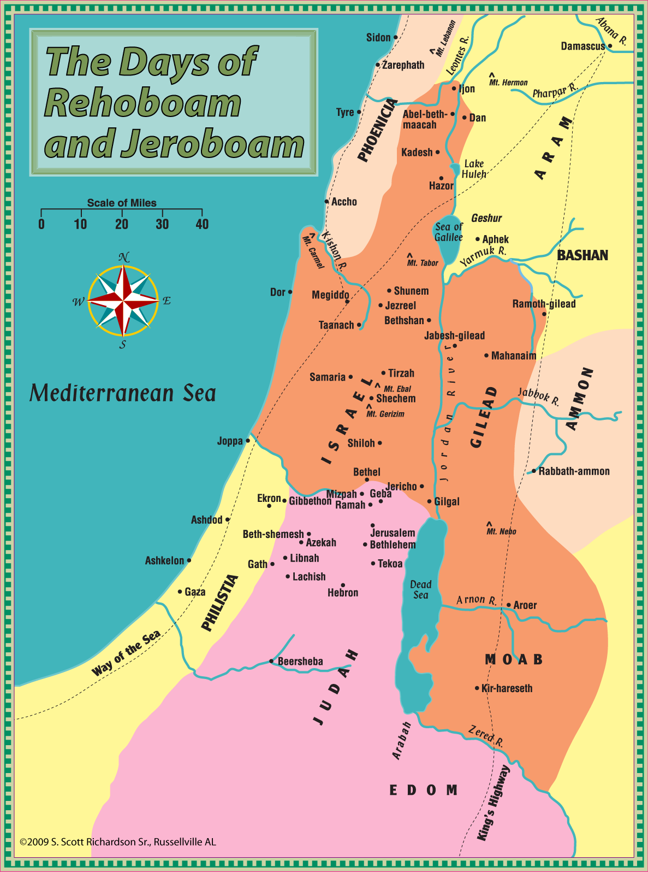

The Days of Jehoahaz and Joash

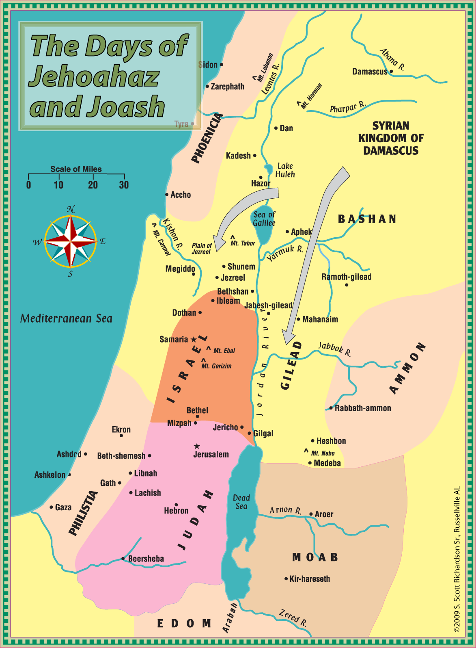

The Assyrian Empire

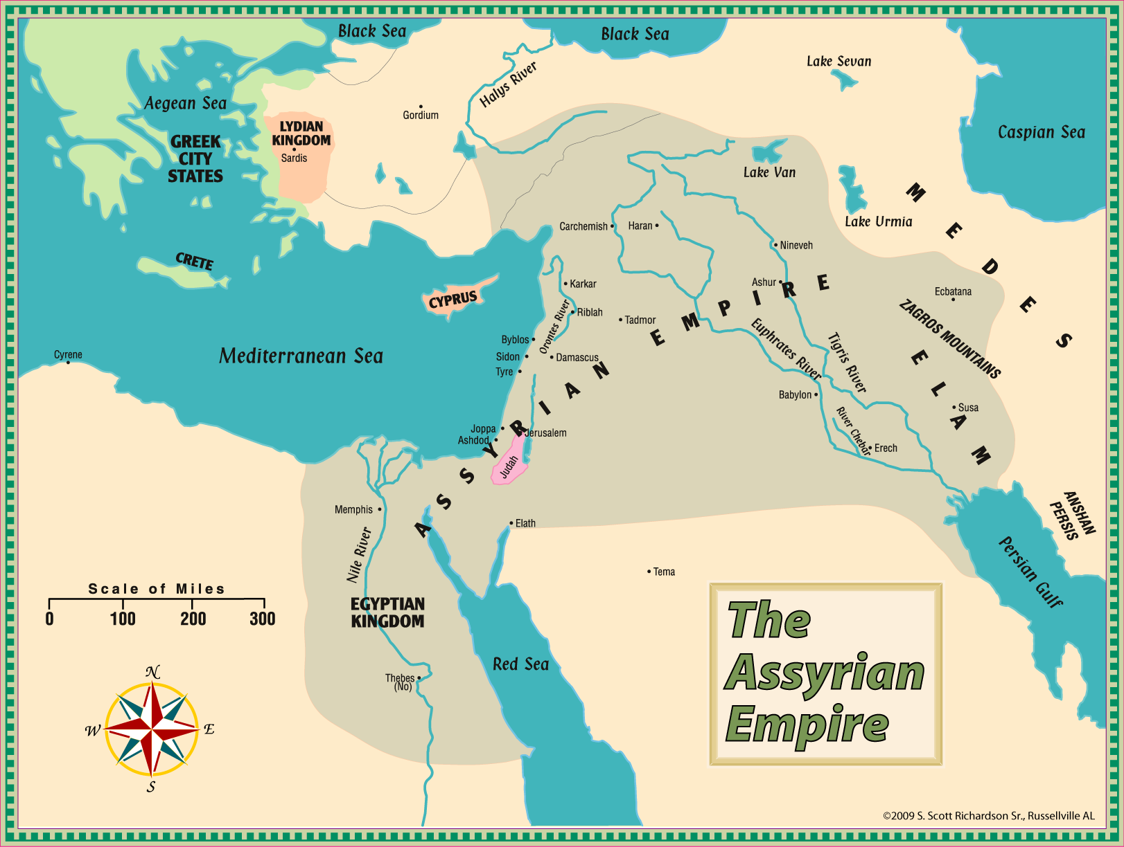

Judah Alone

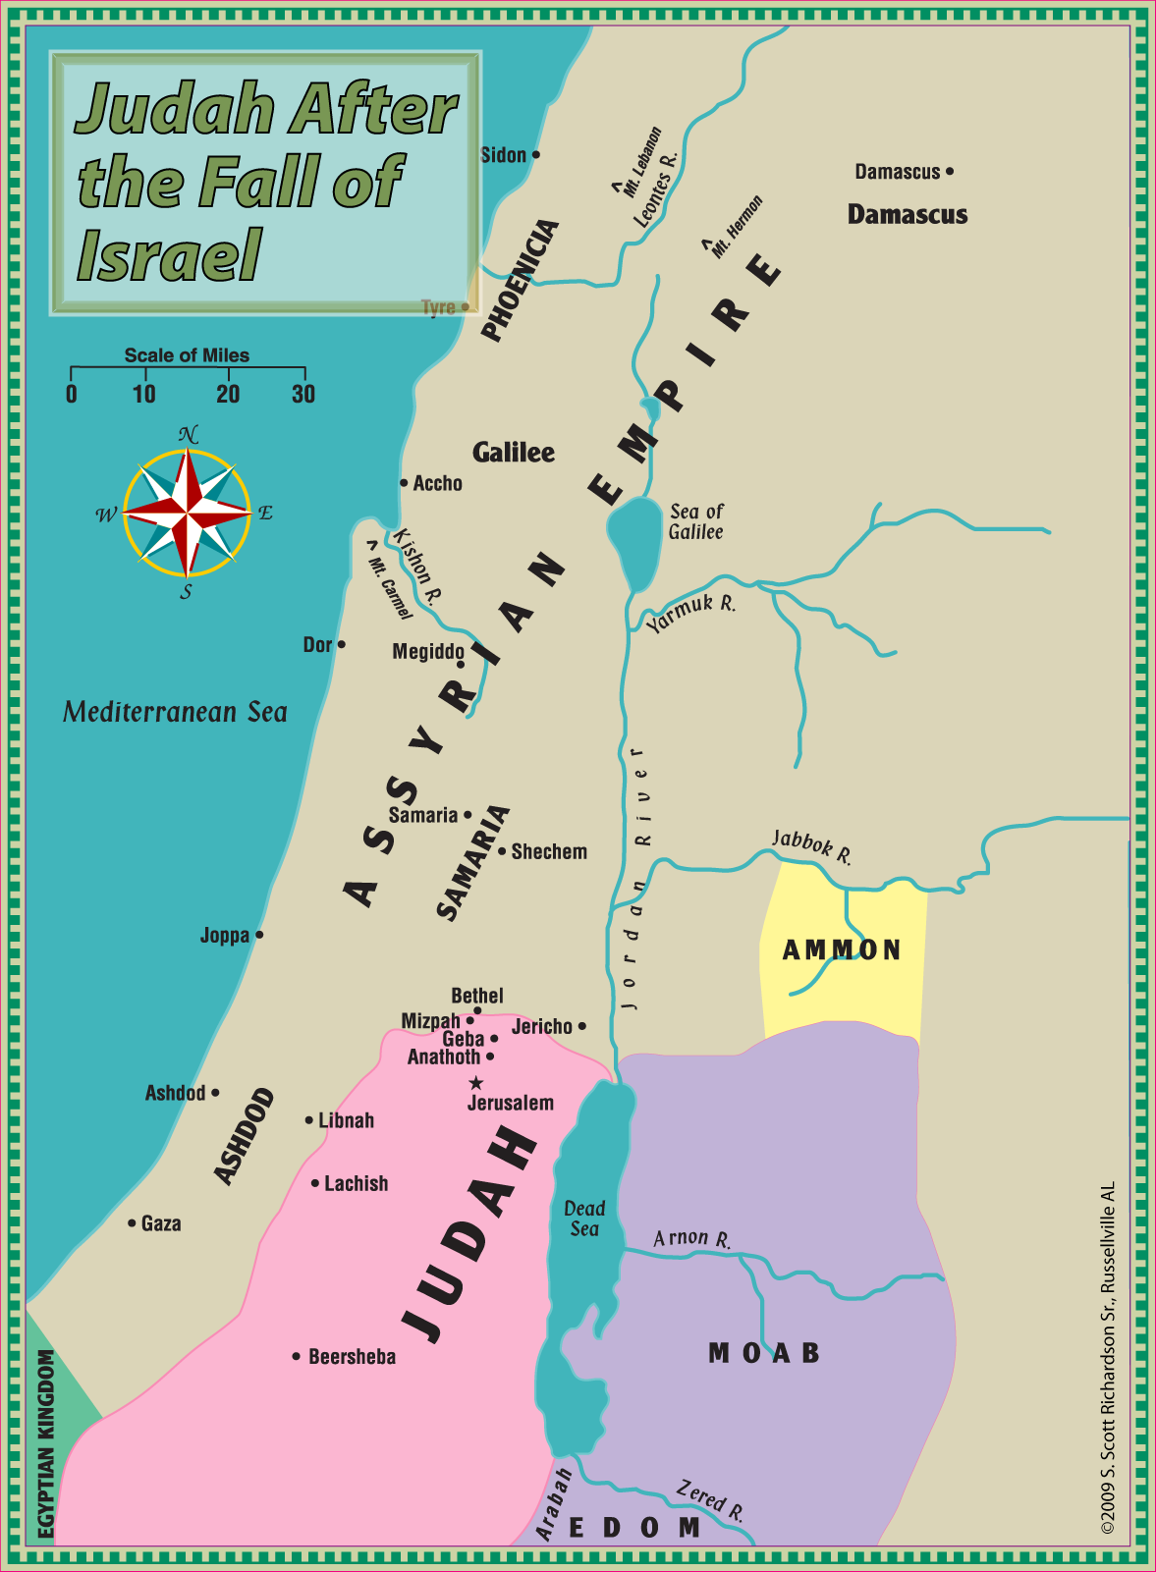

Babylonian Empire

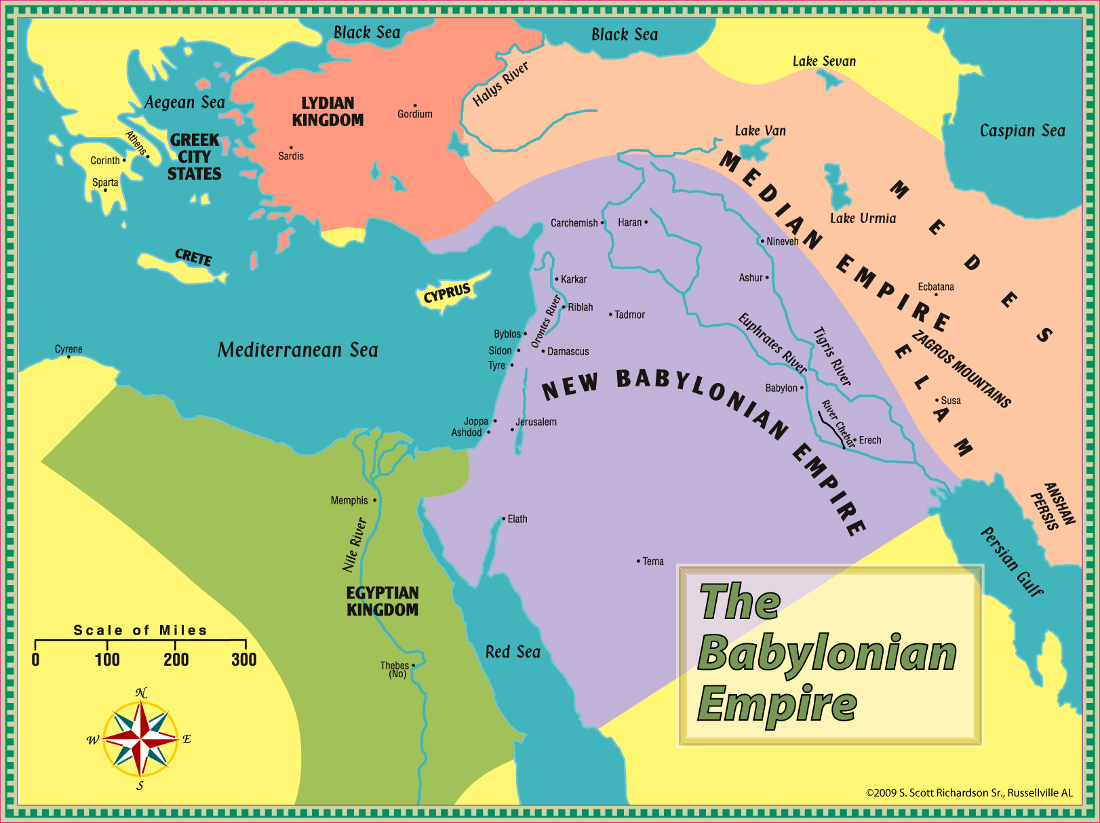

Memory Passages

“In the beginning God created the heavens and the earth. The earth was without form, and void; and darkness was on the face of the deep. And the Spirit of God was hovering over the face of the waters.
Then God said, ‘Let there be light’; and there was light.” Genesis 1:1-3
“Now the Lord had said to Abram: ‘Get out of your country, from your family and from your father's house, to a land that I will show you. I will make you a great nation; I will bless you and make your name great; and you shall be a blessing. I will bless those who bless you, and I will curse him who curses you; and in you all the families of the earth shall be blessed.’ ” Genesis 12:1-3
“Joseph said to them, ‘Do not be afraid, for am I in the place of God? But as for you, you meant evil against me; but God meant it for good, in order to bring it about as it is this day, to save many people alive.’ ” Genesis 50:19-20
“And Moses said to the people: ‘Remember this day in which you went out of Egypt, out of the house of bondage; for by strength of hand the Lord brought you out of this place.’ ” Exodus 13:3
“Now therefore, if you will indeed obey My voice and keep my covenant, then you shall be a special treasure to Me above all people; for all the earth is Mine.” Exodus 19:5
“Then the cloud covered the tabernacle of meeting, and the glory of the Lord filled the tabernacle.” Exodus 40:34
“For I am the Lord who brings you up out of the land of Egypt, to be your God. You shall therefore be holy, for I am holy.” Leviticus 11:45
“Now when the people complained, it displeased the Lord; for the Lord heard it, and His anger was aroused. So the fire of the Lord burned among them, and consumed some in the outskirts of the camp.” Numbers 11:1
“Then the Lord spoke to Moses and Aaron, ‘Because you did not believe Me, to hallow Me in the eyes of the children of Israel, therefore you shall not bring this assembly into the land which I have given them.’ ” Numbers 20:12
“You shall love the Lord your God with all your heart, with all your soul, and with all your strength.” Deuteronomy 6:5
“Not a word failed of any good thing which the Lord had spoken to the house of Israel. All came to pass.” Joshua 21:45
“In those days there was no king in Israel; everyone did what was right in his own eyes.” Judges 17:6
“Only fear the Lord, and serve Him in truth with all your heart; for consider what great things He has done for you. But if you still do wickedly, you shall be swept away, both you and your king.”
1 Samuel 12:24-25
“But the Lord said to Samuel, “Do not look at his appearance or at his physical stature, because I have refused him. For the Lord does not see as man sees; for man looks at the outward appearance, but the Lord looks at the heart.” 1 Samuel 16:7
“I go the way of all the earth; be strong, therefore, and prove yourself a man. And keep the charge of the Lord your God: to walk in His ways, to keep His statutes, His commandments, His judgments, and His testimonies, as it is written in the Law of Moses, that you may prosper in all that you do and wherever you turn.” 1 Kings 2:2-3
Lessons 1-4: “And Elijah came to all the people, and said, ‘How long will you falter between two opinions? If the Lord is God, follow Him; but if Baal, follow him.’ But the people answered him not a word.” 1 Kings 18:21
Lessons 5-8: “For the children of Israel walked in all the sins of Jeroboam which he did; they did not depart from them, until the Lord removed Israel out of His sight, as He had said by all His servants
the prophets. So Israel was carried away from their own land to Assyria, as it is to this day.” 2 Kings 17:22-23
Lessons 9-13: “Thus Josiah removed all the abominations from all the country that belonged to the children of Israel, and made all who were present in Israel diligently serve the Lord their God. All his days they did not depart from following the Lord God of their fathers.” 2 Chronicles 34:33

Lesson One: The Kingdom of Israel Divides
1 Kings 12:1—16:28; (2 Chronicles 10)

- The division of the kingdom was announced in 1 Kings 11 and all need to review that chapter and the reasons the Lord brought about this division.
- Who was brought back from Egypt to be the spokesman for the people when they confronted Rehoboam?
- What were the chief complaints of Israel? Cf. the warnings given by Samuel in 1 Sam. 8.
- What two groups did Rehoboam consult with before making his decision about the grievances of the people?
- Who was Adoram (Hadoram) and why did the people stone him?
- Why didn’t Rehoboam use his army to stop the division of his kingdom?
- The prophet Ahijah had promised Jeroboam an enduring kingdom if he did what? 1 Kings 11
- Why did Jeroboam build two golden calves and change the worship of Israel?
- Who was sent to Bethel to cry out against the altar erected there?
- What happened to Jeroboam when he ordered the arrest of the man of God?
- Why was the man of God killed before he got back to Judah?
- What did Jeroboam have his wife do when their son became sick?
- When did this son die? What was Jeroboam’s wife told would happen to her other sons?
- How long did Jeroboam reign?
- How long did Nadab reign in Israel?
- Watch the number of times the ruling family changes in Israel while the kingdom of Judah remains under the control of David’s descendants.
- Baasha killed Nabad and reigned for _________ years, but was said to walk in the ways of __________________.
- How long did Elah reign?
- How long was the reign of Zimri before he killed himself while under attack from Omri?
- Who was Omri’s rival for control of Israel?
- Omri made ______________ his capital.
- How did the historian describe the wickedness of Omri?

Lesson Two: Wicked King Ahab
1 Kings 16:29—22:50

- How was the wickedness of Omri described in 1 Kgs. 16:25? How is Ahab’s wickedness described in 16:30-33?
- Ahab took as his wife ________________, the daughter of ________________. What is said about her influence on Ahab in 1 Kgs. 21:25?
- What did Hiel do in the days of Ahab and what did it cost him?
- Elijah told Ahab there would be no ____________ or _______________.
- What was Elijah’s first hiding place and how did the Lord feed him there?
- Note the irony of Elijah’s next “hiding place” as he goes to _______________, a city belonging to Sidon.
- How did the widow of Zarephath show her faith in the words of Elijah?
- What did Elijah do to raise the widow’s son back to life?
- Where in the New Testament do we read about the length of this drought?
- What was Ahab doing when Elijah went to present himself before the king?
- How had Obadiah demonstrated his faith in the Lord?
- Ahab called Elijah the “___________________________ of Israel.”
- The KJV and ASV use the singular thou and the plural ye and preserve an important distinction in
1 Kgs. 18:18. Ahab and his father’s house (the plural ye) had forsaken the Lord’s commandments, but it was Ahab (the singular thou) who had followed the Baals.
- How did the people respond when Elijah challenged them to choose between the Lord and Baal?
- Describe the contest to which Elijah challenged the prophets of Baal.

- List the reasons Elijah gave for Baal not responding.
- What did Elijah do to the altar of the Lord to make sure he could not be accused of cheating?

- What did Elijah do as Ahab was returning to Jezreel?
- Why did Elijah go to Beersheba? What was his prayer after leaving his servant and traveling alone into the wilderness?
- What was his response when asked why he was at Horeb?
- When the Lord spoke to Elijah, what two men was he told to anoint?
- The Lord had reserved ______________________ in Israel who had not bowed to Baal.
- How did Elisha demonstrate his wholehearted commitment to following Elijah?
- What was Ahab’s retort to Ben-Hadad when he threatened to level Samaria?
- Ben-Hadad’s servants told him the gods of Israel were gods of the _____________ and he needed to fight against Ahab in the _______________.
- How did a prophet demonstrate to Ahab his error in allowing Ben-Hadad to escape?
- What did Ahab do when Naboth refused to sell him his vineyard?
- How did Jezebel take care of the vineyard problem?
- Where were the dogs going to lick the blood of Ahab?
- How did Ahab react to the harsh rebuke of Elijah?
- Ahab asked Jehoshaphat to help him retake ______________ ___________________, but Jehoshaphat wanted to consult with the Lord.
- How many prophets promised Ahab and Jehoshaphat success?
- What was Micaiah’s explanation for the prophets promising success?
- How was Ahab killed?

Lesson Three: God’s Men, Elijah and Elisha
1 Kings 22:51-53; 2 Kings 1-4

- Note: Following the precise chronology of the kings of Israel and Judah is difficult.
1 Kings 16—2 Kings 7 rarely mentions the kings of Judah, but instead focuses on the wickedness of the house of Ahab and the spiritual warfare waged by Elijah and Elisha. On the other hand, while 2 Chronicles may occasionally mention a king of Israel because of their interaction with the Judah, the focus is exclusively on the kings of Judah and doesn’t often help us to synchronize the kings.
- Till There Was No Remedy by Bob and Sandra Waldron does a good job of trying to synchronize them as much as the information will allow and I highly recommend the book as a companion to this study.
- However, what is most important is not the chronology or God would have had the books written differently. Focus on learning the lessons intended by the inspired writers.
- How long did Ahaziah reign in Israel?
- How was Ahaziah injured and to whom did he turn to inquire about his chances of recovery?
- When Elijah intercepted the messengers, what were they told to tell the king?
- How many men perished trying to arrest Elijah?
- Why was it different for the third captain?
- Who became king of Israel after Ahaziah?
- What did Elisha insist on doing when Elijah told him to stay behind?
- What question did the sons of the prophets ask Elisha?
- How did Elijah get across the Jordan?
- How was Elijah taken up into heaven?
- Elisha crossed the Jordan by smiting the water with the _____________ of Elijah.
- What miracle did Elisha perform in Jericho?
- Why were some young men mauled by bears?
- How was Jehoram of Israel different from his father and mother?
- When did the king of Moab rebel against Israel’s dominion?
- Jehoram enlisted the help of Jehoshaphat and the king of _______________.
- What caused Jehoshaphat to ask if a prophet of the Lord was present?
- Why did Elisha agree to help?

- Verse 16 is a difficult verse to translate. It can rendered as a command as in most translations, e.g. “Make this valley full of ditches” (NKJV), or it can also be rendered as a statement of what will be done as in the ESV, “I will make this dry streambed full of pools.” Whether they were to do any digging or simply watch, the miracle was in the water flowing in from elsewhere to fill the land between the armies of the three kings and the army of Moab.
- What did the Moabites think when they saw the sun reflecting on the water?
- How did Jehoram and his men damage the land of Moab?
- What did the king of Moab do when the battle seemed hopeless?
- How did Elisha help the widow of one of the sons of the prophets?
- Be sure to locate Shunem on your map.
- What did the woman of Shunem and her husband do for Elisha?
- What favor did Gehazi suggest be done for her?
- What was Gehazi told to do with the staff of Elisha?
- Cf. the raising of the widow’s son in 1 Kings 17 with this story in 2 Kings 4. List both the similarities and the differences.

- How did the stew at Gilgal become poisoned?
- With what did Elisha feed one hundred men?

Lesson Four: Elisha and Naaman
2 Kings 5-9

- How is Naaman described in 5:1?
- How did a young girl from Israel come to serve Naaman’s wife?
- What was the reaction of the king of Israel when Naaman brought him the letter from the king of Syria?
- Elisha said, “Please let him come to me, and he shall know that there is a _____________ in Israel.”
- Why did Naaman become angry when Elisha told him what he needed to do?

- When was Naaman cleansed of his leprosy?
- Where did Naaman go after being cleansed?
- Why did Naaman want two mule-loads of earth?
- Why did Gehazi chase after Naaman?
- What curse was put on Gehazi?
- What miracle did Elisha perform when the sons of the prophets were cutting trees near the Jordan?
- How did Elisha aid the king of Israel in ch. 6?
- What was Elisha’s response when his servant was made afraid by the Syrian army?
- To what city did Elisha lead the blinded Syrians?
- Ben-Hadad besieged the city of Samaria and food became so scarce that a ______________ was being sold for eighty shekels of silver.
- What upset the king and caused him to threaten the life of Elisha?
- Why was one of the king’s officers told he would never eat of the bounty the Lord was going to provide?
- Four _______________ decided to surrender to the Syrians but found the camp empty.
- What did the four men do before deciding to inform the king?
- A seah was approximately 6 ½ quarts. What was the going rate for flour after the Syrian army fled?
- Why did the Shunnamite woman go to Philistia for seven years?
- What did Elisha do when Hazael met him with gifts from Ben-Hadad?
- How did Ben-Hadad die?
- Where was Jehu when anointed king and who anointed him?
- How did Jehu’s men react to the news he had been anointed?
- What question did Joram ask of Jehu?
- On what piece of ground was the body of Joram thrown?
- Who killed Ahaziah, king of Judah?
- How did Jezebel die and what was done to her body?

Lesson Five: The End of Israel
2 Kings 10; 13; 14:23-29; 15:8-31; 17

- Review: How did Jehu become king and what three leaders did he immediately kill?
- What did Jehu challenge the elders of Samaria to do? What did he tell them to do when they declined to challenge the authority of Jehu?
- How many of Ahaziah’s kinsmen did Jehu kill?
- Jehu invited Jehonadab to witness his zeal for _____________________.
- What did Jehu do to eliminate the worship of Baal from Israel?
- Though Jehu waged war on the worship of Baal, he did not turn away from the sins of __________________.
- What enemy, during the reign of Jehu, took the territory east of the Jordan?
- Jehoahaz followed in the sins of _______________.
- Jehoash/Joash of Israel was also said to have walked in the sins of ________________.
- Thought question. Why would a wicked king like Joash weep at the imminent death of Elisha?
- Why did Elisha become angry with Joash?
- Joash/Jehoash was able to defeat Syria ____________ times because the Lord showed compassion because of the covenant with _____________________________________.
- What sin did Jeroboam (II) commit?
- Yet Jeroboam II restored much of Israel’s territory in fulfillment of the prophecy of _____________.
- How long did Zechariah reign? Who killed him?
- Who killed the king that killed Zechariah?
- How much silver did Israel have to give to Pul (Tiglath-Pileser III)?
- Pekahiah reigned for __________ years before being killed by Pekah.
- What portions of Israel did Tiglath-Pileser take during the reign of Pekah?
- Hoshea became a vassal to _________________, but was discovered sending messengers to So, king of _________________.
- The siege of Samaria lasted _______________ years.
- List the different causes for the Assyrian captivity found in 2 Kgs. 17:5-18.
- Who was brought in to live in the cities of Samaria instead of the children of Israel?
- Why did these new inhabitants request that a priest be sent to them?
- “They feared the ____________, yet served their ____________________.”

Lesson Six: Kings of Judah
2 Chronicles 11-22; 1 Kings 14:21—15:24; 2 Kings 11:1-3

- Who left Israel and strengthened the southern kingdom of Judah? 2 Chron. 11:13-17
- How many wives did Rehoboam have? 2 Chron. 11
- What did Egypt take from Jerusalem during the days of Rehoboam? 1 Kgs. 14; 2 Chron. 12
- Who became king after Rehoboam? Was he faithful to the Lord? How was he able to defeat Jeroboam in battle?
- List the good things Asa did as king of Judah.

- In the days of Asa Judah was strengthened by people coming from what three tribes?
- In what ways did Asa fail?
- What did Jehoshaphat do to bring about spiritual reform in Judah? 2 Chron. 17
- In 2 Chron. 19 Jehoshaphat was rebuked because he helped the ______________ and ____________ those who hated the Lord.
- How were Jehoshaphat and Judah able to defeat the great armies in 2 Chron. 20?
- What did Jehoram of Judah do to solidify his hold on the kingdom after his father Jehoshaphat died?
- Jehoram walked in the ways of the kings of ______________, for he had the daughter of _________ as his wife.
- Who invaded Judah in the time of Jehoram?
- What caused Jehoram’s death?
- Who was Ahaziah’s mother?
- Ahaziah was said to have walked in the ways of whom?
- Who killed Ahaziah?
- Why had Ahaziah gone to Jezreel?
- What did Athaliah do when she saw that Ahaziah had been killed?
- Who saved Joash and kept him hidden for six years?

Lesson Seven: King Joash and the Temple
2 Kings 11-12; 14:1-22; 15:1-7, 32-38; 16:1-20; 2 Chronicles 23-28

- Review: How did Athaliah become the ruler of Judah and who had kept Joash safe?
- Who aided Jehoiada in putting Joash (Jehoash) on the throne?
- What was given to Joash when they crowned him king?
- What was the cry of Athaliah when she realized what was happening?
- Who was to be killed with Athaliah?
- What was done to the temple of Baal?
- Joash was __________ years old when he became king and he reigned for ____________ years.
- What had the priests and Levites failed to collect from Judah?
- Though Joash was zealous to repair the temple of the Lord, who persuaded him to turn from God after the death of Jehoiada?
- What prophet did Joash order to be killed?
- How was a small company of Syrians able to defeat Joash’s larger army?
- How did Joash die?
- Why didn’t Amaziah execute the children of the men who had killed his father?
- Why was Amaziah told not to take the men of Israel with him into battle against Edom?
- What did the soldiers from Israel do after they were discharged by Amaziah?
- What gods did Amaziah begin to worship after defeating Edom?
- Joash, king of Israel, compared Amaziah, king of Judah, to a ________________ plant.
- How much of the wall of Jerusalem was broken down by Israel?
- Where was Amaziah killed?
- How old was Uzziah (Azariah) when he became king of Judah?
- How long did he reign?
- Uzziah prospered as long as he did what?
- What was said to have led to his destruction?
- Who tried to stop him from burning incense on the altar of incense?
- How was Uzziah punished for this transgression?
- List the good accomplishments of Jotham.
- What wicked acts did Ahaz commit?
- What king did Ahaz ask for help when attacked by Israel and Syria?
- Why did Israel return the captives they had taken from Judah?
- With what did King Ahaz replace the bronze altar that was before the temple of the Lord?
- What other two nations attacked Judah during the reign of Ahaz? 2 Chron. 28:17-18

Lesson Eight: Good King Hezekiah
2 Kings 18:1—21:18; 2 Chronicles 29:1—33:20; (Isaiah 36-39)

- Hezekiah was king of Judah during the time the Assyrians carried Israel into captivity and the Assyrians were a great threat to Judah during his reign.
- How old was Hezekiah when he became king? How long did he reign?
- When did Hezekiah begin the task of repairing the temple?
- Pay careful attention to all the things done in 2 Chron. 29:20-36 when Hezekiah restored the temple worship.
- Hezekiah sent messengers and invited all ______________ from ______________ to ________________ to come to Jerusalem to keep the Passover.
- How were the messengers of Hezekiah received?
- Why did Hezekiah have to pray for the Lord to provide atonement for some who had eaten the Passover?
- What did they cut down and break after observing the Passover?
- Why did Hezekiah destroy the bronze serpent Moses had made?
- Hezekiah wanted the people to provide support for the priests and Levites so that they might devote themselves to what?
- List the things Hezekiah did to prepare for war in 2 Chron. 32:1-6.

- What reason did he then give for not being afraid of the Assyrians?
- Sennacherib told Hezekiah the king of Egypt was a ____________ ______________ and he should not rely on him for help.
- Why did Hezekiah’s men request that Sennacherib’s men speak to them in Aramaic?
- Isaiah assured Hezekiah that Sennacherib would fall by the _____________ in _________ _________ land.
- What did Hezekiah do with the threatening letter from the Assyrian king?
- How many were killed by the angel of the Lord?
- Who killed Sennacherib?
- How long was Hezekiah’s life extended when he begged to be spared?
- What did Hezekiah do when the Babylonian king sent envoys to him?
- How old was Manasseh when he became king? How long did he reign?
- What great evils did Manasseh commit?
- What measuring line and plummet did the Lord intend to use on Jerusalem?
- What caused Manasseh to repent?
- What reforms did Manasseh undertake after his repentance?
- After reading about Manasseh’s repentance and reforms, turn and read 2 Kings 24:1-4.

Lesson Nine: The End of Judah
2 Kings 21:19—25:30 (2 Chronicles 33:21—36:23)

- Who was Amon’s father?
- How was the character of Amon described?
- Who killed Amon?
- How old was Josiah when he became king ca. 640 B.C.?
- What did Josiah begin to do in the eighth year of his reign? 2 Chr. 34
- List the things he did in the twelfth year of his reign and the different territories he went into.

- Note: Jeremiah began to prophesy in Judah in Josiah’s 13th year.
- What were they doing in his eighteenth year when they found the book of the Law?
- When the Law was read to Josiah, he tore ___________________ and sent men to inquire of ____________________.
- Summarize the message of the prophetess Huldah.

- Note carefully that Josiah did not give in to despair; instead, he led the people in a renewal of the covenant and tried even harder to rid the land of idolatry.
- What did he do that fulfilled a prophecy made in 1 Kings 13?
- 2 Chron. 35 contains a more detailed account of the Passover Josiah instructed the people to keep.
- Historical note: The Babylonians under Nabopolassar had gained their independence from Assyria in 625 B.C. Then ca. 612 B.C. the Babylonians combined forces with the Medes to overthrow Nineveh. A greatly weakened Assyria shifted its capital to Carchemish and in 609 B.C. Pharaoh Necho wanted to help the Assyrians against Babylon. (A weakened, but allied Assyria would have been a buffer between Egypt and the growing power of Babylon.)
- Who killed Josiah and where did it happen?
- Jehoahaz took Josiah’s place but only reigned for ___________ months before being taken to ________________.
- After Jehoahaz was carried away, Necho made _______________ king and changed his name to ____________________. (Note: The kingship moved from brother to brother and not father to son this time.)
- 2 Kings 24:1 speaks of Nebuchadnezzar making Jehoiakim a vassal king and from Daniel 1 we learn that he took a relatively small group of captives to Babylon at this time.
- Though sin was widespread in Judah, what one king is given more blame than any other?
- How long did Jehoiachin (Jeconiah/Coniah) reign?
- It was probably 597 B.C. when Jehoiachin and a large group from Judah were taken captive.
- __________________’s name was changed to Zedekiah. (This is the third son of Josiah to reign.)
- Why did Nebuchadnezzar lay siege to Jerusalem in Zedekiah’s ninth year?
- In what year of Zedekiah’s reign did Jerusalem fall?
- What did Zedekiah have to witness before having his eyes put out?
- What did Nebuzaradan do to the temple?
- Who was left as governor over the remnant left behind in Judah?
- Why did this remnant flee to Egypt? (See Jer. 40-43 for more about the remnant and its move to Egypt.)

Lesson Ten: Jonah—a Prophet to Nineveh
Jonah 1-4; 2 Kings 14:23-27

- What Israelite king enjoyed great success as prophesied by Jonah?
- Be sure to locate Tarshish, Joppa, and Nineveh on a map.
- What message was Jonah told to proclaim and why?
- What was Jonah doing when the great storm was hurled upon the sea?
- How did the sailors figure out that the storm was sent because of Jonah?
- What did Jonah tell them they would have to do to calm the storm?
- What was the prayer of the men before they threw Jonah into the sea?
- How long was Jonah in the belly of the fish?
- Jonah described his prayer as going into God’s holy __________________.
- What did Jonah do the second time he was told to go to Nineveh?
- What was his message to that great city?
- What did the king do when he heard about the preaching of Nineveh?
- How did God respond to the repentance of Nineveh? Cf. Jer. 18:1-10.
- What reason did Jonah give for having originally tried to flee to Tarshish?
- How did the Lord first comfort Jonah and then cause him to be miserable?
- Jonah was concerned about the death of a ________________, while the Lord was concerned about whom and what?
- Locate the New Testament references to Jonah. How is his story used by Jesus?

Lesson Eleven: Hosea—A Prophet to Israel
Hosea 1-14; (2 Kings 14:23—17:41)

- Read Hosea 1:1. While Hosea was primarily a prophet to Israel, it is interesting to note that the only king of Israel he mentions is Jeroboam II, the one in whose reign he began to prophesy. But if we look at the kings of Judah he mentions and compare those names against their contemporaries in Israel, we know that his work extended into the reigns of Zechariah, Shallum, Menahem, Pekahiah, Pekah, and Hoshea.
- When in the reigns of Uzziah and Jeroboam II Hosea began his work is uncertain, but most place it ca. 750 B.C. At this time both Israel and Judah were enjoying a time of prosperity and expansion.
- Hosea’s work ended during the reign of Hoshea, the last king of Israel. The fall of Samaria is usually put at 721 B.C. and Hosea seems to have ended his work shortly before that, perhaps ca. 725 B.C.
- What woman was Hosea told to marry?
- List the three children and the significance of each name.

- 1:10—2:1 and 2:14—3:5 speak of Israel’s restoration. While some physical element may have been intended, see Rom. 9:24-26 and 1 Pet. 2:9-10 for the main point.
- Whom would the restored Israel seek as their king? Ch. 3
- What was the Lord’s charge or indictment in 4:1-2?
- Why were God’s people being destroyed and whom did the Lord hold responsible for it? Ch. 4
- What was Judah warned against in 4:15-17?
- To whom did Israel/Ephraim turn when he realized he needed help? 5:13
- What did the Lord desire more than sacrifice and burnt offerings? 6:6
- Where in the New Testament do we find this quoted?
- In ch. 7 Hosea compared Israel to a person who did not realize he was turning gray and to a silly dove. What was meant by each of these analogies?

- Where in the New Testament do we have language similar to that of 10:8 regarding people crying out to the mountains and hills?
- Where in the New Testament do we see 11:1 quoted?
- What were Admah and Zeboiim? 11:8
- List the things Israel was urged to do in 12:6.
- To what three animals did the Lord compare Himself in 13:7-8?
- Israel was called upon to return to the Lord and not look to ___________________ for their deliverance.

Lesson Eleven: Isaiah—A Prophet to Both Judah and Israel
Isaiah 1:1—2:4; 3:13-26; 6:1—7:20; 9:1-7; 10:1—13:22; 31:1-9; 35:1-10; 40:1-31; 44:24—45:7; 52:13—53:12; 55:1-13; 59:1-4; 61:1-9; 64:1-12; 66:1-2

- Isaiah’s time of prophesying is usually dated from ca. 740 B.C. to 700 B.C. This means his work overlapped that of Hosea in Israel and Micah in Judah.
- Isaiah began his work before the fall of Samaria and the Assyrian Captivity in 721 B.C. and then continued into the time of Judah Alone.
- Before the fall of Israel he prophesied to both nations, though his emphasis was on Judah.
- Though Judah was spared by the Assyrians Isaiah foresaw the Babylonian Captivity.
- A major part of his message was intended to give hope during the captivity and to the remnant that returned. His Messianic prophecies offered hope of a glorious future.
- With sixty-six chapters we cannot look at all the great passages in this book, but we will look at some of the sins that would bring God’s wrath on Israel and Judah, and then the hope he promised through the Servant of the Lord.
- What did he begin the book by saying Israel did not know?
- Why did the Lord reject their worship? Ch. 1
- If they would allow it, their sins could go from ________________ to being as white as __________________.
- Who would come to the Lord’s house in the latter days?
- Those in the Lord’s house would beat their ____________________ into _____________________, and their ________________________ into ____________________.
- What sin(s) did Isaiah focus on in 3:13-22?
- Describe what Isaiah saw in the same year that King Uzziah died.

- After accepting the call to prophesy, how long was he to continue his work?
- Where in the New Testament is 9:1-2 quoted?
- List the different names given the Messiah in 9:6.
- “Woe to Assyria, the ______________ of My anger, and the ______________ in whose hand is my indignation.” 10:5
- “They shall not _____________ nor ________________ in all My holy mountain.” 11:9
- Locate the New Testament quotation of 11:10.
- “For great is the _____________________ of Israel in your midst.” 12:6
- The judgment language of Isa. 13 can help in understanding the similar language in Matt. 24, Mark 13, and Luke 21.
- Against what nation is the judgment of ch. 13 directed?
- What would happen to the stars, sun, and moon?
- Ch. 40 begins the second great section of the book and was intended to provide hope for those taken into captivity.
- A great emphasis in this second portion of the book is the might and majestic power of God—don’t doubt His ability to deliver on His promises!
- 40:3-5 is quoted in the New Testament in reference to the work of __________ the ____________.
- Who would mount up with wings like eagles?
- Take note of the terms applied to Cyrus, future king of Persia, in ch. 44, 45.
- “My ______________.” 44:28
- “My ______________.” 45:1
- 52:13—53:12 is commonly referred to as the Servant Song. Find at least three places where portions of this are quoted in the New Testament.
- What were the people told to stop spending their “money” on in ch. 55?
- What caused the separation between God and His people in ch. 59?
- Where was Jesus when He announced that Isa. 61 was being fulfilled in their hearing?
- Upon whom would the Lord look with favor? 66:2

Lesson Thirteen: Joel—A Prophet to Judah
Joel 1-3

- Joel is one of the few prophets that cannot be given a definitive timeframe. While some believe the book to have been written as early as 830 B.C., others argue for a time near the close of the Old Testament period.
- While we can’t be certain about the when of Joel, we do know it was prompted by an invasion of locusts sent by the Lord as a warning that an even more severe judgment would follow if they did not repent.
- Who was to be told about this plague of locusts? 1:2-3
- Why were the drunkards to weep?
- They were to consecrate a ______________ and call a sacred _________________ so that they might cry out to _____________________.
- Why was the trumpet to be blown in Zion?
- While in Isaiah 10 the Lord spoke of using Assyria as His tool of judgment, here in Joel the locusts are called His great army. 2:11, 25
- They were called upon to tear their ______________ and not their _______________.
- Read the description of the Lord in 2:13 and list the different attributes found here.

- 2:18-27 seems to depict the blessings that would come on physical Judah if they repented, but beginning in 2:28 the prophet looks to the distant future and speaks of both the blessings and the judgments of the Messianic era.
- Where in the New Testament is 2:28-32 quoted?
- While ch. 3 has its difficulties, 3:1 points us to the same time period as 2:28-32. The Lord, through the prophet Joel, uses the people, nations, and circumstances of the Old Testament to speak of judgment upon New Testament enemies and blessings upon His spiritual Zion.
- What were the nations told to do with their plowshares and pruning hooks?
- The sun and moon might grow dark, but the Lord would be a ________________ for His people.

Appendix: The Prophets

1. Key prophetic themes. (All of these are not found in every prophetic book, but these themes recur often throughout the prophets.)
a. The necessity of repentance.
b. The Day of the Lord.
1) The Day of the Lord signified God’s judgment on a nation, usually at the hands of another nation.
c. God’s concern for all the nations.
d. The coming of the Messiah and the new spiritual order.

2. Some great lessons that stand out in the writings of the prophets.
a. God hates and punishes sin.
b. Yet, God is also merciful.
c. The Lord keeps His promises for good and bad.
d. God’s providence rules in the nations for the advancement of His cause and His people.
e. The great majesty of the Lord is emphasized.

Prophet | Time Period | Date | Prophesied to…*
Isaiah | Divided Kingdom; Judah Alone | Ca. 740-700 B.C. | Judah
Jeremiah | Judah Alone; Babylonian Captivity | Ca. 627-586 B.C. | Judah
Ezekiel | Babylonian Captivity | Ca. 593-573 B.C. | Judah
Daniel | Babylonian Captivity | Ca. 605-537 B.C. | **
Hosea | Divided Kingdom | Ca. 750-725 B.C. | Israel
Joel | Divided Kingdom (?) | Uncertain; possibly ca. 830 B.C. | Judah
Amos | Divided Kingdom | Ca. 760-755 | Israel
Obadiah | Divided Kingdom  Or Judah Alone | Uncertain; ca. 845 B.C. or 586 B.C. | Edom
Jonah | Divided Kingdom | Ca. 790 B.C. | Nineveh
Micah | Divided Kingdom; Judah Alone | Ca. 735-700 B.C. | Judah
Nahum | Judah Alone | Between 663 and 612 B.C.; most likely time between 640 and 625 B.C. | Nineveh (a message of comfort to Judah regarding the fall of Nineveh)
Habakkuk | Judah Alone | Ca. 609-606 B.C. | Judah
Zephaniah | Judah Alone | Reign of Josiah; likely between 640 and 625 B.C. | Judah
Haggai | Return and Rebuilding | 520 B.C. | Judah
Zechariah | Return and Rebuilding | 520-? B.C. | Judah
Malachi | Return and Rebuilding | Possibly before Ezra and Nehemiah or ca. 425 B.C. | Judah

*Many of the prophets directed their message to more than one nation, but these are the primary recipients/targets of their prophecies.

**Daniel, as a servant of Babylon and Persia, did not preach directly to the people as other prophets did, but his prophecies looked to the future of God’s people and God’s dealings with the kingdoms of men.

